Project 2 Proposal

Nate Bach – Sean Hoffman – Christine Robicheaux – Sean Stroh

Repository: <https://github.com/seanhoffman76/Economic-Growth-Project>

# Global Economic Growth over Time

**SYNOPSIS:** Our chosen project is an analysis of the economic growth of nations over time. We are planning to contrast increased GDP to increases in life expectancy and total population over time. For our visualizations, we will be offering users the ability to change the time range for our population and life expectancy graphs so that the user analysis can be more customizable. To provide this information in a meaningful way, we’re planning on utilizing datasets from the following sources:

* **TOTAL OUTPUT-SIDE REAL GDP AT CHAINED PPPS (TOT_RGDP_O) (PWT 9.1 (2019))**
  + 183 countries - annual total output-side real GDP (2011 US$)) from 1950-2017 (where available)
  + Source: Max Roser (2020) - "Economic Growth". Published online at OurWorldInData.org. Retrieved from: '<https://ourworldindata.org/economic-growth>' [Online Resource]
  + Link: <https://ourworldindata.org/grapher/national-gdp>
* **POPULATION BY COUNTRY (CLIO INFRA (2016))**
  + 190 countries – population recorded at intervals from 1500-2000 (where available)
  + Source: Max Roser (2020) - "Economic Growth". Published online at OurWorldInData.org. Retrieved from: '<https://ourworldindata.org/economic-growth>' [Online Resource]
  + Link: <https://ourworldindata.org/grapher/population-by-country>
* **API_SP.POP.TOTL_DS2_en_csv_v2_887275.csv**
  + 264 countries – population recorded annually from 1960-2018 (where available)
  + Source: ( 1 ) United Nations Population Division. World Population Prospects: 2019 Revision. ( 2 ) Census reports and other statistical publications from national statistical offices, ( 3 ) Eurostat: Demographic Statistics, ( 4 ) United Nations Statistical Division. Population and Vital Statistics Reprot ( various years ), ( 5 ) U.S. Census Bureau: International Database, and ( 6 ) Secretariat of the Pacific Community: Statistics and Demography Programme.
  + Link: <https://data.worldbank.org/indicator/SP.POP.TOTL?end=2018&start=1960&view=map&year=1960>
  + Metadata:
    - Metadata_Country_API_SP.POP.TOTL_DS2_en_csv_v2_887275.csv
    - Metadata_Indicator_API_SP.POP.TOTL_DS2_en_csv_v2_887275.csv
* **LIFE EXPECTANCY**
  + 243 entities (countries and/or continent/region) – life expectancy recorded at intervals from 1543-2019 (where available)
  + Source: Max Roser (2020) - "Economic Growth". Published online at OurWorldInData.org. Retrieved from: '<https://ourworldindata.org/economic-growth>' [Online Resource]
  + Link: <https://ourworldindata.org/grapher/life-expectancy>

Some of the visualization types that we plan on utilizing for this project include the following:

* Bar Chart Race via D3.js (<https://observablehq.com/@d3/bar-chart-race>) to illustrate the changes in GDP, Population Growth, and Life Expectancy over the course of time.
* 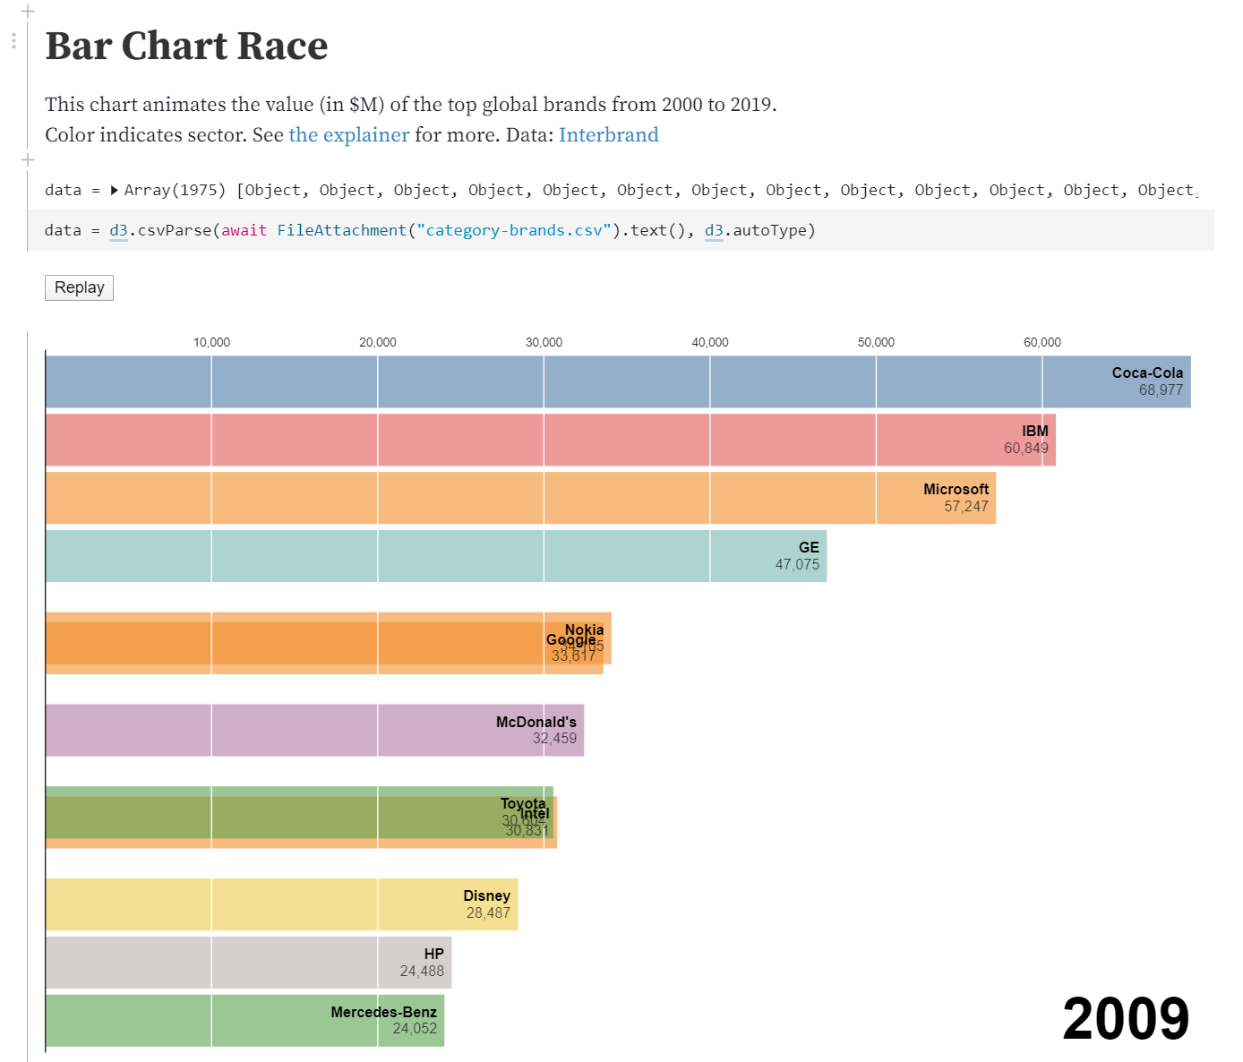 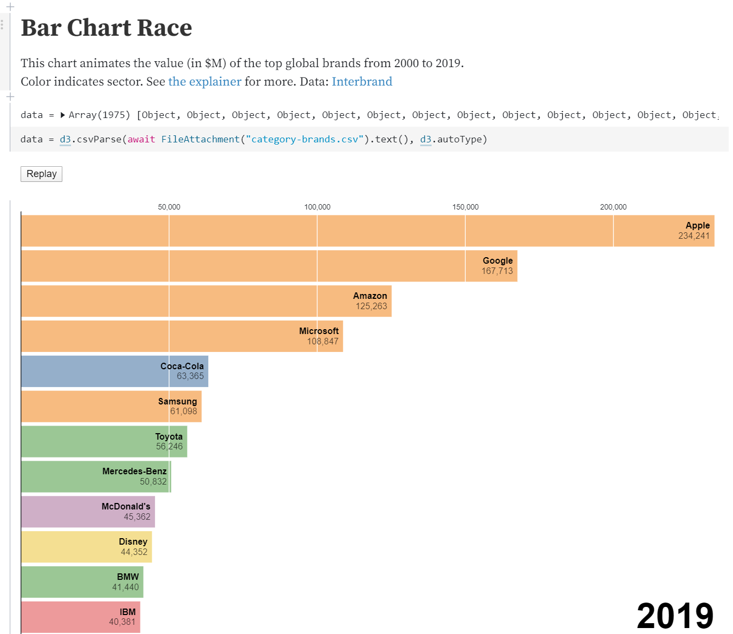
* Multi-layer mapping of GDP, Population Growth, Life Expectancy using Leaflet.js
* 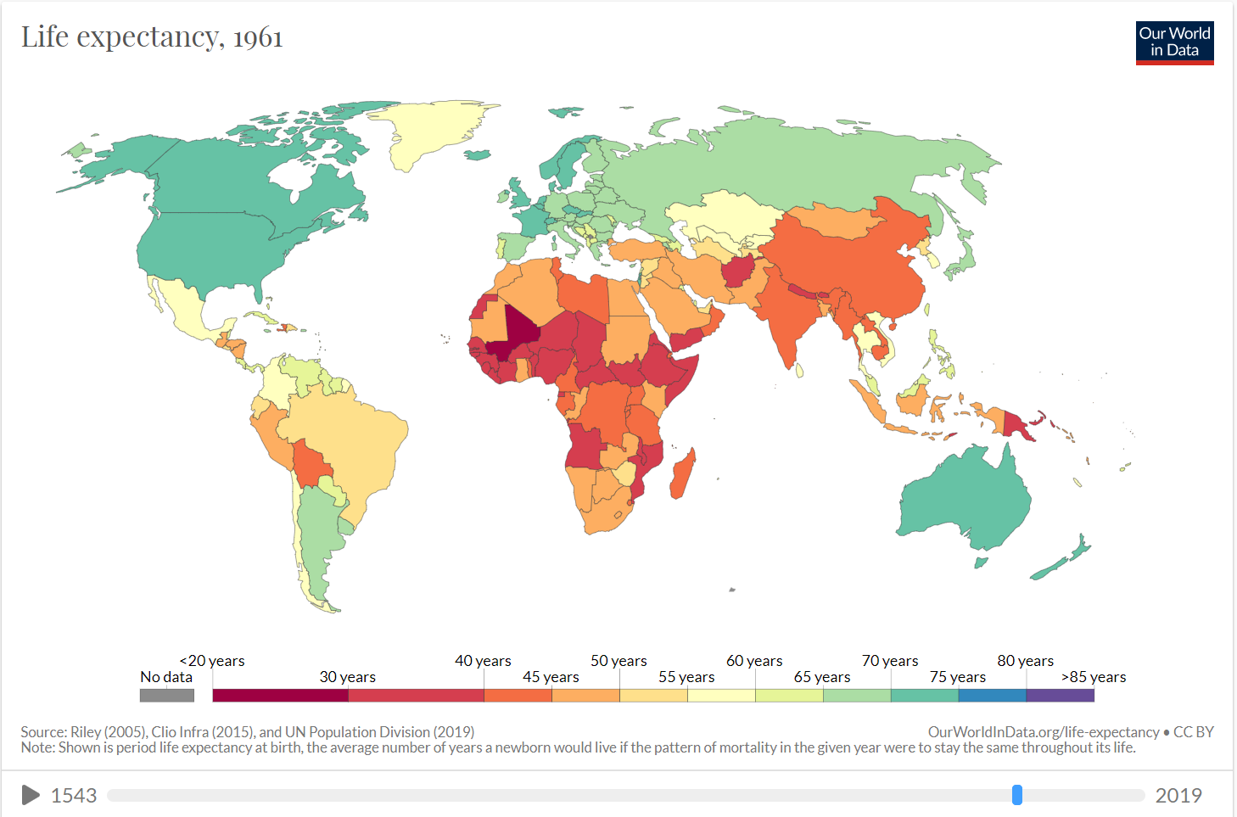
* Various additional responsive plots using D3.js

